Quiz #4: Magnetic Fields of a Wire, Circuits
Questions 1 and 2 refer to the following diagram.

9 AMPS

A

- A wire carries a current of 9 amps to the right, as shown. What is the magnetic field strength at point A, located 3 cm below the wire?
  - 0 T
  - 3p x 10⁻⁷ T
  - 6 x 10⁻⁵ T
  - 1.5 x 10⁻³ T
  - None of the Above

- A second wire carries an equal amount of current as the wire in question #1. Which configuration would cause the magnetic force between the wires to always be attractive?
  - Horizontal, parallel to the first wire, carrying current to the right.
  - Horizontal, antiparallel to the first wire, carrying current to the left.
  - Perpendicular to the first wire, carrying current toward the top of the page.
  - Perpendicular to the first wire, carrying current into the page.
  - None of these orientations guarantee attractive force.

Question 3-4 refer to the following diagram

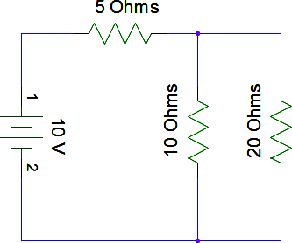
- What is the equivalent resistance of the circuit in the diagram?
  - 2.857 W
  - 4.286 W
  - 11.666 W
  - 35 W
  - 10 000 W

- Which of the following statements is true concerning the voltages of the 5, 10, and 20 ohm resistors?
  - V₅ > V₁₀ > V₂₀
  - V₁₀ > V₂₀ > V₅
  - V₁₀ = V₂₀ > V₅
  - V₅ > V₁₀ = V₂₀
  - V₂₀ > V₁₀ > V₅

- A capacitor has a capacitance of 0.1 Farads. A voltage of 400 volts is applied to the capacitor. What is the charge stored in the capacitor?
  - 400 C
  - 40 C
  - 2.5 C
  - 0.25 C
  - 0.0025 C

- A current of 5 amps passes through a resistor of R = 3 W. What is the power dissipated by the resistor?
  - 3 W
  - 5 W
  - 15 W
  - 45 W
  - 75 W

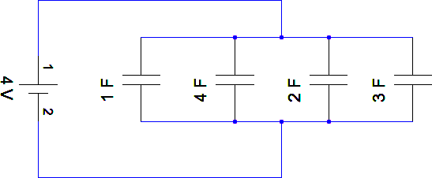
Questions 7 and 8 refer to the following diagram

- What is the voltage drop across the 4 F capacitor?
  - 0.25 V
  - 1 V
  - 4 V
  - 16 V
  - 64 V

- What is the total charge stored in the circuit?
  - 0.48 C
  - 4 C
  - 33.33 C
  - 40 C
  - There is not enough information to solve this problem

- What is the function of Inductors, Capacitors, and Resistors?

 | Inductor | Capacitor | Resistor
(a) | Stores energy in a magnetic field | Stores energy in an electric field | Dissipates energy as heat
(b) | Dissipates energy as heat | Stores energy in a magnetic field | Stores energy in an electric field
(c) | Stores energy in an electric field | Dissipates energy as heat | Stores energy in a magnetic field
(d) | Stores energy in an electric field | Stores energy in a magnetic field | Dissipates energy as heat
(e) | Stores energy in an electric field | Dissipates energy as heat | Stores energy in a magnetic field

- A current of 3 amps is flowing in a simple circuit with one resistor. If another resistor is added to the circuit, the current will be -
  - Less than 3 Amps
  - Exactly 3 Amps
  - More than 3 Amps
  - It cannot be determined without knowing the resistances of the resistors and the voltage of the source
  - It cannot be determined without knowing if the resistor is added in parallel or series.

